# Microsoft Office Usage

# Word How Tos

Very useful for formatting etc.:

<http://guides.lib.umich.edu/word2010>

* **Captions for tables should be above and captions for figures should be below.**

## Inserting Captions for Figures

1. Copy the caption wording to your clipboard (omit the word figure)
2. Select the image
3. On the ribbon, click the references tab
4. Click the Insert Caption button
5. Caption field will have already been pre-populated with “Figure ?”, paste in the wording (label) from the clipboard. Change “Label:” to Table if you are applying the caption to a table.  
   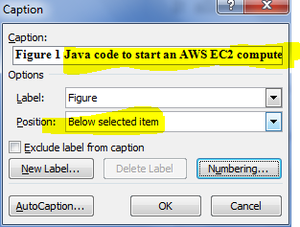
6. You can then optionally add a Harvard reference at the end of the caption, this will be included in table of figures.
7. Optionally update the “Table of Figures” (and or “Table of Tables”) by updating it in the same way as a table of contents

€